**Supporting Information**

**Does the Intra-atomic Deformation Energy of IQA Represent Steric Energy?**

Benjamin C. B. Symons, Campbell M. Brooks, Dominic Williamson, Alex L. Wilson, and Paul L. A. Popelier

Manchester Institute of Biotechnology (MIB), 131 Princess Street, Manchester M1 7DN, Great Britain and

School of Chemistry, University of Manchester, Oxford Road, Manchester M13 9PL, Great Britain

**1. Theta scans**

1.1 NH3 dimer

**Table S1.** Energy ranges and exponential fit data for NH3 theta scan. Energy ranges and fit data are calculated from a sum of the data for both approaching atoms, whereas volume data pertains to a single atom.

|  |  |  |  |  |  |  |  |
| --- | --- | --- | --- | --- | --- | --- | --- |
| **Theta** | **RMS Error (kJ/mol)** | **Energy Range (kJ/mol)** | **Min Energy (kJ/mol)** | **Max Energy (kJ/mol)** | **Coefficient A** | **Coefficient B** | **Compression of Atomic Volume (%)** |
| 0 | 1.8 | 304.7 | 1.3 | 306.0 | 40,375 | 2.2475 | -16.9 |
| 10 | 1.7 | 299.4 | 1.5 | 300.9 | 39,068 | 2.2402 | -17.1 |
| 20 | 1.3 | 287.7 | 2.1 | 289.8 | 36,108 | 2.2218 | -17.3 |
| 30 | 0.6 | 278.4 | 3.3 | 281.8 | 33,034 | 2.1951 | -17.3 |
| 40 | 0.6 | 280.8 | 5.3 | 286.1 | 31,319 | 2.1654 | -17.0 |
| 50 | 1.5 | 299.8 | 7.6 | 307.4 | 31,414 | 2.1356 | -16.6 |
| 60 | 2.3 | 333.6 | 9.8 | 343.4 | 33,492 | 2.1148 | -15.5 |
| 70 | 2.4 | 378.4 | 11.2 | 389.6 | 37,283 | 2.1056 | -14.3 |
| 80 | 2.0 | 434.8 | 11.3 | 446.1 | 48,126 | 2.1595 | -13.1 |
| 90 | 1.3 | 509.9 | 9.2 | 519.2 | 81,843 | 2.3319 | -11.4 |
| 100 | 0.7 | 602.3 | 5.6 | 607.8 | 175,659 | 2.6104 | -9.4 |
| 110 | 1.2 | 682.8 | 2.4 | 685.2 | 332,009 | 2.8483 | -7.6 |
| 120 | 1.6 | 721.8 | 1.6 | 723.4 | 368,860 | 2.8716 | -7.1 |
| 130 | 1.1 | 691.4 | 3.3 | 694.8 | 239,181 | 2.6907 | -7.5 |
| 140 | 0.9 | 612.1 | 6.0 | 618.1 | 134,908 | 2.4829 | -8.9 |
| 150 | 2.2 | 531.1 | 7.8 | 539.0 | 86,255 | 2.3420 | -10.2 |
| 160 | 2.7 | 470.3 | 8.8 | 479.1 | 65,407 | 2.2702 | -11.7 |
| 170 | 3.1 | 434.8 | 9.3 | 444.1 | 56,966 | 2.2422 | -12.9 |
| 180 | 3.4 | 423.0 | 9.4 | 432.3 | 54,446 | 2.2345 | -13.2 |

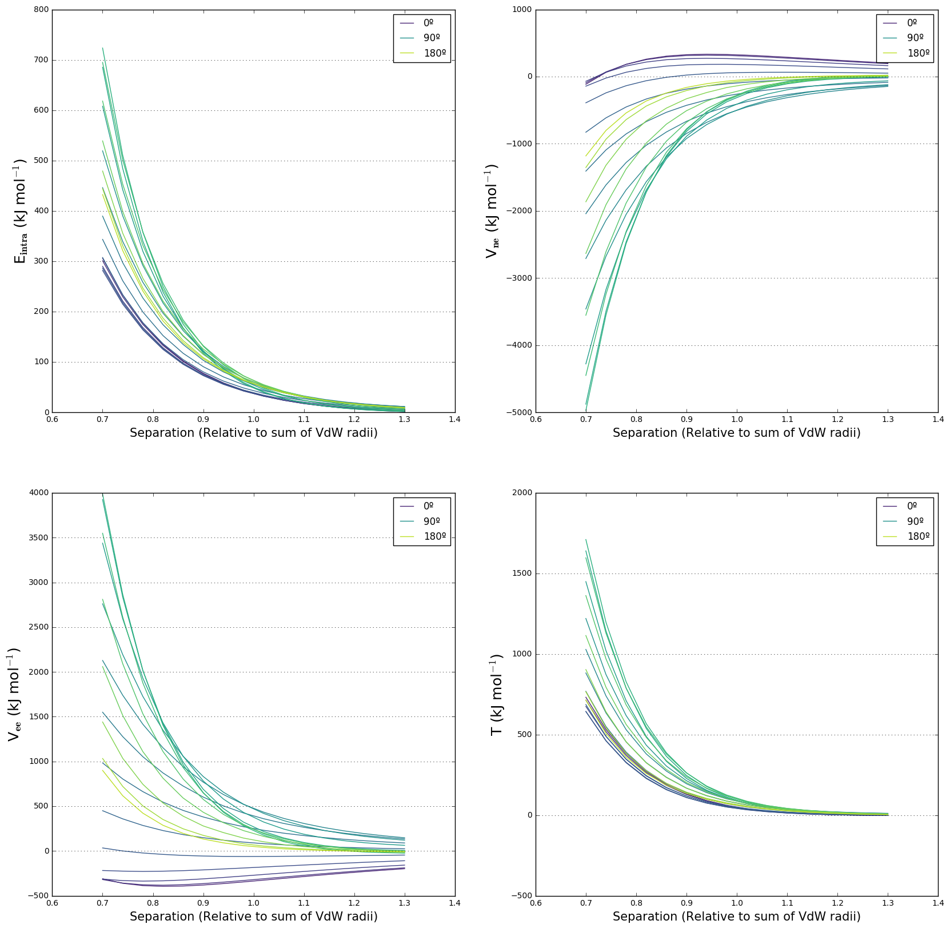

**Figure S1.** Intra-atomic energy and its contributions for all values of θ in the scan.

1.2 H2O dimer

**Table S2.** Energy ranges and exponential fit data for H2O theta scan. Energy ranges and fit data are calculated from a sum of the data for both approaching atoms, whereas volume data pertains to a single atom.

|  |  |  |  |  |  |  |  |
| --- | --- | --- | --- | --- | --- | --- | --- |
| **Theta** | **RMS Error (kJ/mol)** | **Energy Range (kJ/mol)** | **Min Energy (kJ/mol)** | **Max Energy (kJ/mol)** | **Coefficient A** | **Coefficient B** | **Compression of Atomic Volume (%)** |
| 0 | 2.8 | 190.5 | -3.2 | 187.3 | 65,662 | 2.7477 | -9.9 |
| 10 | 2.6 | 191.3 | -2.9 | 188.4 | 63,103 | 2.7267 | -9.9 |
| 20 | 2.2 | 193.5 | -2.1 | 191.4 | 56,842 | 2.6713 | -10.1 |
| 30 | 1.6 | 197.3 | -0.9 | 196.4 | 48,380 | 2.5850 | -10.4 |
| 40 | 0.8 | 203.5 | 0.7 | 204.2 | 40,040 | 2.4799 | -10.9 |
| 50 | 0.5 | 214.8 | 2.8 | 217.6 | 33,280 | 2.3657 | -11.6 |
| 60 | 1.4 | 235.3 | 5.3 | 240.6 | 29,326 | 2.2612 | -12.5 |
| 70 | 2.4 | 269.6 | 8.1 | 277.8 | 27,956 | 2.1733 | -13.7 |
| 80 | 3.4 | 320.4 | 11.2 | 331.6 | 29,592 | 2.1177 | -15.2 |
| 90 | 3.8 | 384.2 | 14.0 | 398.1 | 33,300 | 2.0860 | -16.6 |
| 100 | 3.2 | 452.7 | 15.8 | 468.5 | 38,219 | 2.0703 | -17.7 |
| 110 | 3.0 | 522.0 | 16.0 | 537.9 | 46,504 | 2.0925 | -18.3 |
| 120 | 4.1 | 593.7 | 13.7 | 607.4 | 66,023 | 2.1973 | -17.9 |
| 130 | 4.2 | 654.3 | 9.6 | 663.9 | 110,550 | 2.3980 | -16.5 |
| 140 | 3.1 | 665.1 | 5.3 | 670.4 | 177,409 | 2.6174 | -14.8 |
| 150 | 1.7 | 625.1 | 2.7 | 627.9 | 207,343 | 2.7235 | -13.6 |
| 160 | 0.9 | 603.0 | 3.0 | 606.0 | 174,785 | 2.6627 | -12.7 |
| 170 | 1.3 | 608.9 | 5.0 | 613.9 | 129,850 | 2.5178 | -12.0 |
| 180 | 1.1 | 453.2 | 6.1 | 459.3 | 109,152 | 2.4336 | -10.0 |

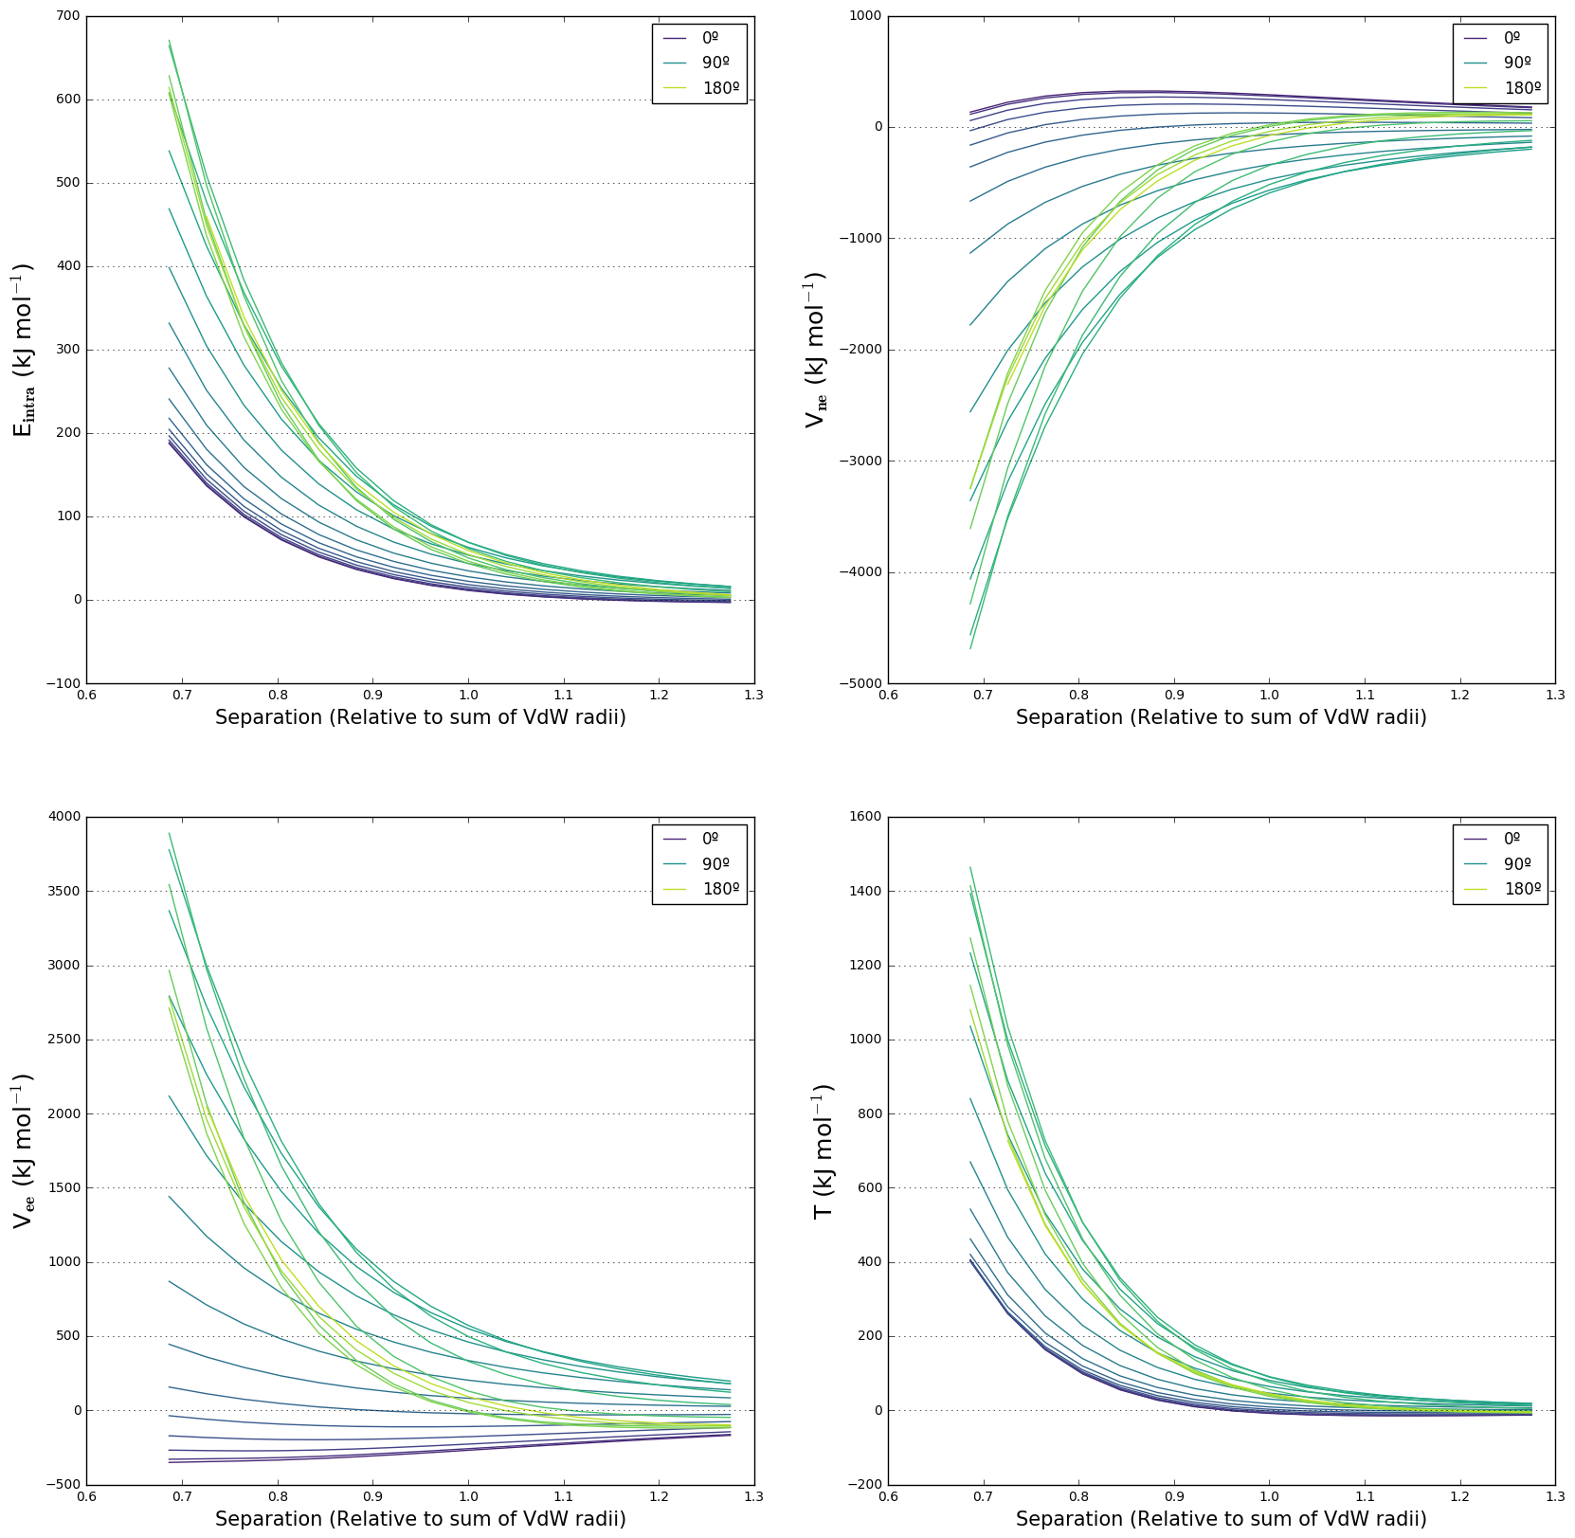

**Figure S2.** Intra-atomic energy and its contributions for all values of θ in the scan.

1.3 HF dimer

**Table S3.** Energy ranges and exponential fit data for HF theta scan. Energy ranges and fit data are calculated from a sum of the data for both approaching atoms, whereas volume data pertains to a single atom.

|  |  |  |  |  |  |  |  |
| --- | --- | --- | --- | --- | --- | --- | --- |
| **Theta** | **RMS Error (kJ/mol)** | **Energy Range (kJ/mol)** | **Minimum Energy (kJ/mol)** | **Maximum Energy (kJ/mol)** | **Coefficient A** | **Coefficient B** | **Compression of Atomic Volume (%)** |
| 0 | 1.9 | 147.4 | 4.5 | 151.9 | 22,194 | 2.4299 | -7.6 |
| 10 | 1.9 | 148.9 | 4.4 | 153.3 | 22,841 | 2.4393 | -7.7 |
| 20 | 1.9 | 153.2 | 4.3 | 157.5 | 24,520 | 2.4604 | -7.8 |
| 30 | 1.8 | 160.1 | 4.1 | 164.2 | 26,693 | 2.4810 | -8.0 |
| 40 | 1.6 | 168.7 | 3.8 | 172.5 | 29,010 | 2.4967 | -8.1 |
| 50 | 1.3 | 177.8 | 3.4 | 181.3 | 31,321 | 2.5088 | -8.5 |
| 60 | 1.0 | 186.3 | 3.0 | 189.3 | 33,936 | 2.5258 | -8.7 |
| 70 | 0.8 | 193.4 | 2.4 | 195.8 | 37,222 | 2.5533 | -9.0 |
| 80 | 0.6 | 199.1 | 1.8 | 201.0 | 41,176 | 2.5888 | -9.3 |
| 90 | 0.5 | 205.2 | 1.4 | 206.6 | 45,373 | 2.6218 | -9.7 |
| 100 | 0.5 | 214.4 | 1.3 | 215.7 | 48,432 | 2.6321 | -10.2 |
| 110 | 0.5 | 230.2 | 1.9 | 232.0 | 48,766 | 2.6005 | -10.6 |
| 120 | 0.9 | 255.4 | 3.3 | 258.7 | 45,998 | 2.5204 | -11.0 |
| 130 | 1.5 | 293.5 | 5.6 | 299.2 | 42,918 | 2.4164 | -11.5 |
| 140 | 1.7 | 347.5 | 8.1 | 355.6 | 42,680 | 2.3291 | -11.5 |
| 150 | 2.1 | 427.1 | 9.1 | 436.1 | 63,271 | 2.4174 | -11.5 |
| 160 | 3.6 | 405.5 | 7.8 | 413.3 | 99,405 | 2.6662 | -12.1 |
| 170 | 2.4 | 9.1 | 5.7 | 14.8 | 74 | 0.5811 | -11.8 |
| 180 | 5.0 | 41.8 | -37.7 | 4.0 | -14,673,600 | 5.3069 | -11.1 |

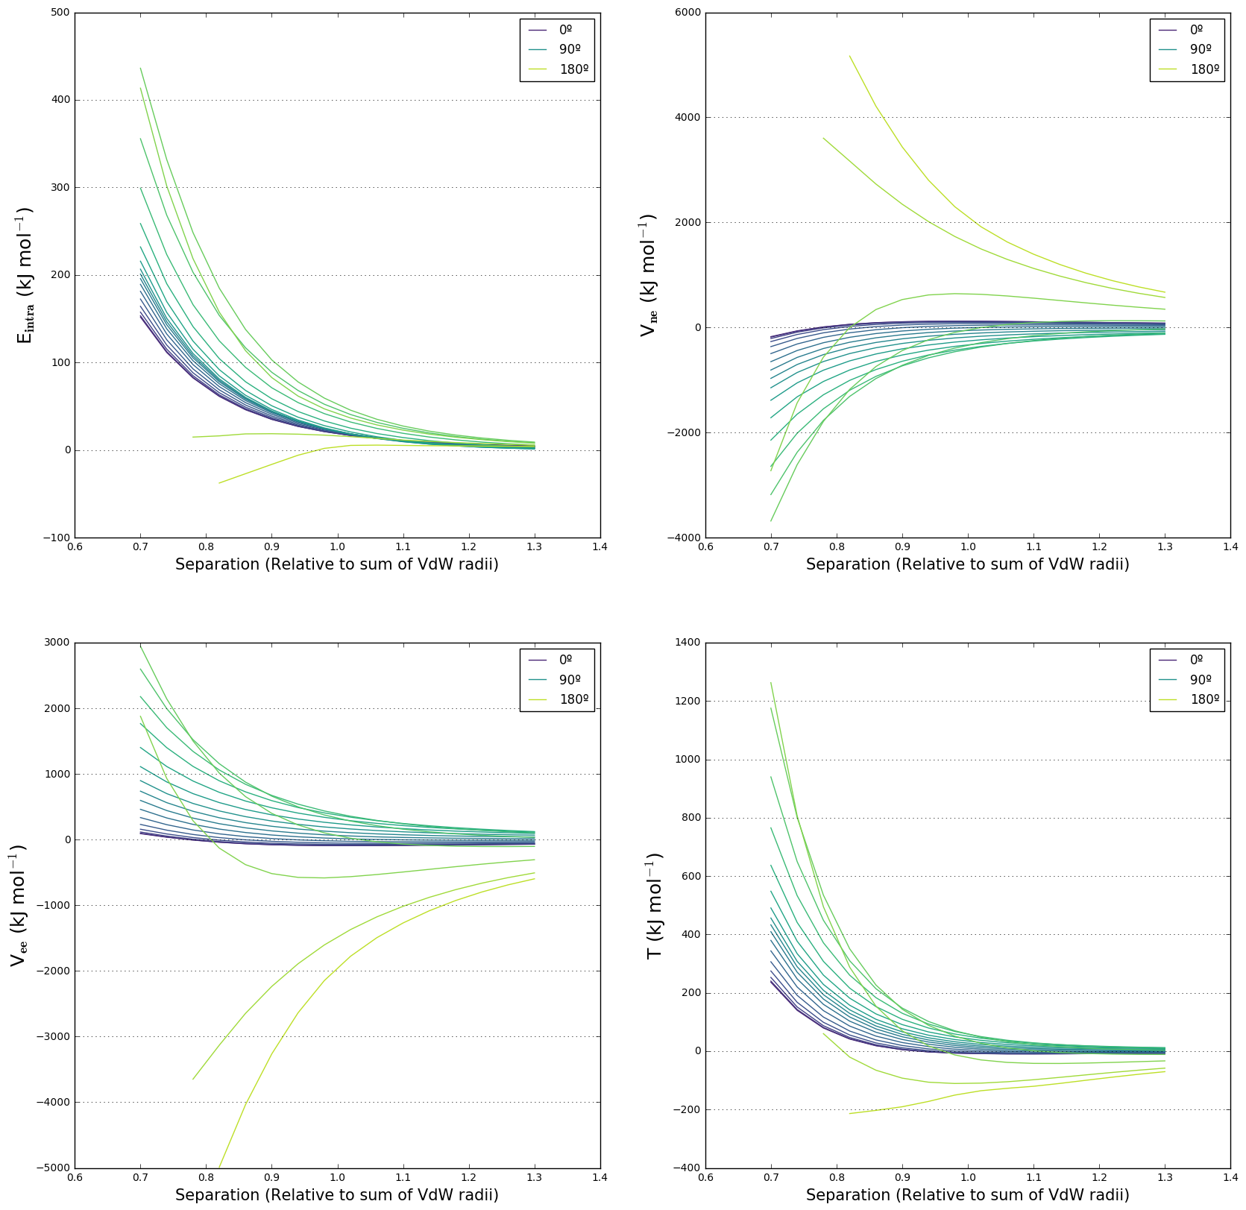

**Figure S3.** Intra-atomic energy and its contributions for all values of θ in the scan.

The deterioration of quality of the fits for the HF dimer theta scan discussed in the main text and shown in Tables 1 and S3 is reflected in some odd trends in the intra-atomic energy contributions at the largest values of θ shown in Figure S3. Note also that, while there is still significant volume compression of the fluorine atoms at the larger values of theta, we showed in the main text that this compression does not occur through-space and so the interaction is not steric.

1.4 N2 dimer

**Table S4.** Energy ranges and exponential fit data for N2 theta scan. Energy ranges and fit data are calculated from a sum of the data for both approaching atoms, whereas volume data pertains to a single atom.

|  |  |  |  |  |  |  |  |
| --- | --- | --- | --- | --- | --- | --- | --- |
| **Theta** | **RMS Error (kJ/mol)** | **Energy Range (kJ/mol)** | **Min Energy (kJ/mol)** | **Max Energy (kJ/mol)** | **Coefficient A** | **Coefficient B** | **Compression of Atomic Volume (%)** |
| 0 | 1.9 | 238.8 | 5.9 | 244.7 | 32,313 | 2.2556 | -13.7 |
| 10 | 1.6 | 225.5 | 5.6 | 231.1 | 29,016 | 2.2313 | -13.2 |
| 20 | 0.9 | 194.0 | 4.8 | 198.8 | 22,812 | 2.1878 | -12.5 |
| 30 | 0.4 | 158.6 | 3.6 | 162.2 | 17,880 | 2.1673 | -11.4 |
| 40 | 0.2 | 127.8 | 2.4 | 130.2 | 14,891 | 2.1831 | -10.6 |
| 50 | 0.3 | 106.6 | 1.3 | 107.9 | 14,106 | 2.2437 | -10.1 |
| 60 | 0.4 | 98.7 | 0.7 | 99.4 | 16,197 | 2.3454 | -9.8 |
| 70 | 0.3 | 106.5 | 0.7 | 107.1 | 21,300 | 2.4378 | -9.8 |
| 80 | 0.1 | 132.3 | 1.2 | 133.5 | 29,477 | 2.4876 | -10.2 |
| 90 | 0.5 | 179.9 | 2.3 | 182.1 | 40,899 | 2.4969 | -11.6 |

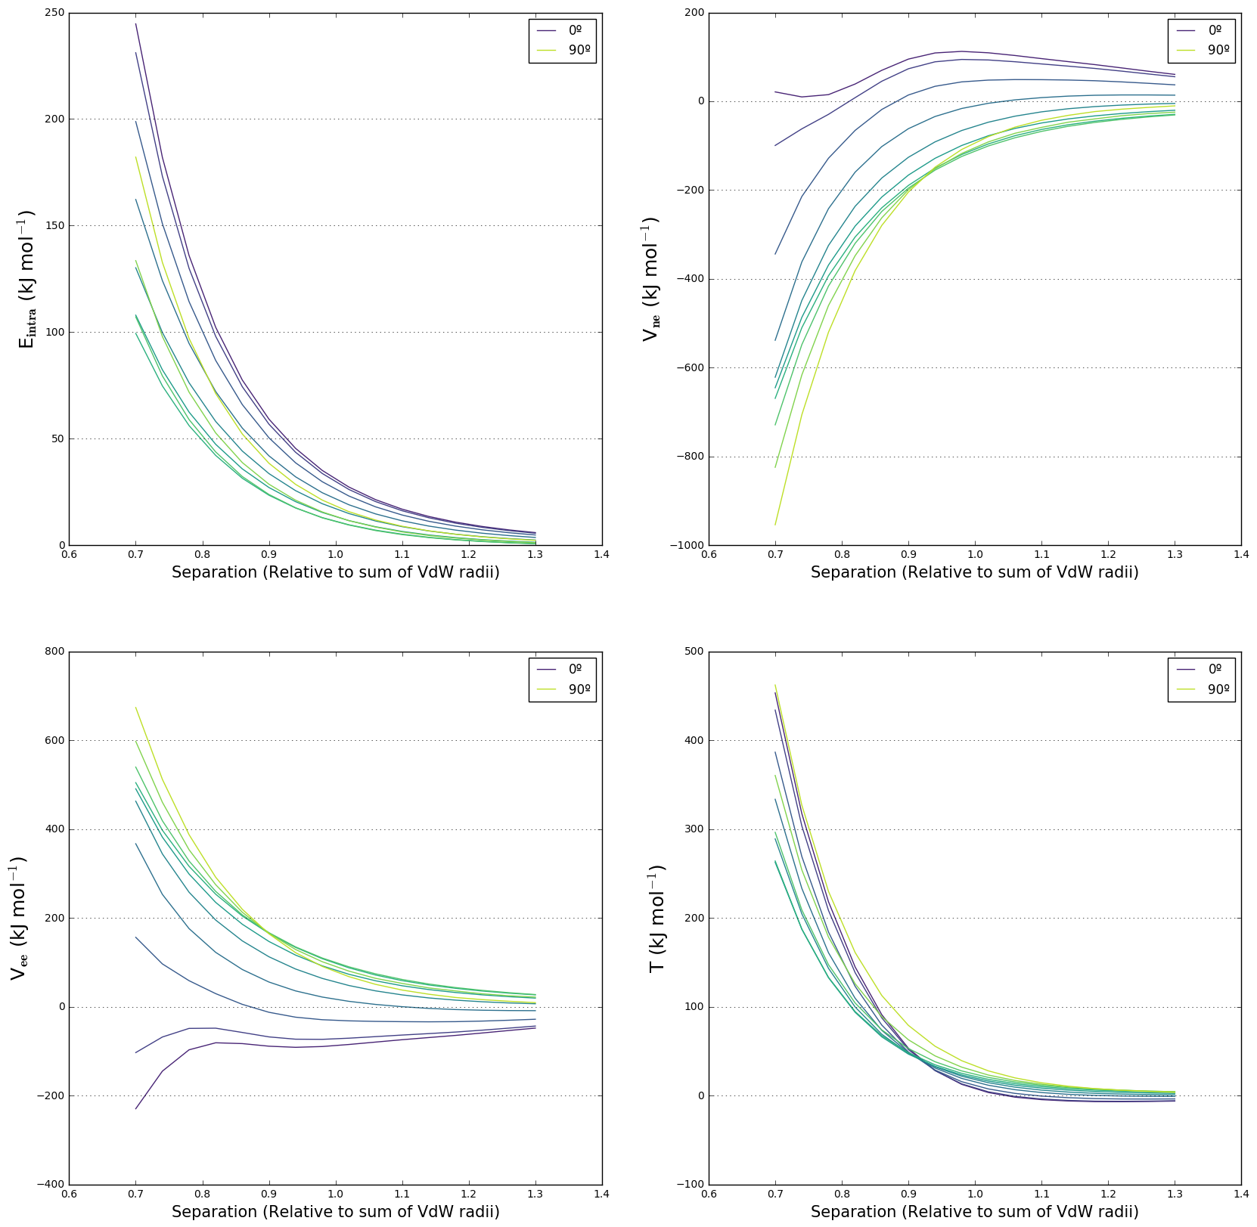

**Figure S4.** Intra-atomic energy and its contributions for all values of θ in the scan.

1.5 O2 dimer

**Table S5.** Energy ranges and exponential fit data for O2 theta scan. Energy ranges and fit data are calculated from a sum of the data for both approaching atoms, whereas volume data pertains to a single atom.

|  |  |  |  |  |  |  |  |
| --- | --- | --- | --- | --- | --- | --- | --- |
| **Theta** | **RMS Error (kJ/mol)** | **Energy Range (kJ/mol)** | **Min Energy (kJ/mol)** | **Max Energy (kJ/mol)** | **Coefficient A** | **Coefficient B** | **Compression of Atomic Volume (%)** |
| 0 | 2.6 | 188.7 | 7.8 | 196.5 | 5,517 | 1.5491 | -8.0 |
| 10 | 2.6 | 192.3 | 8.2 | 200.5 | 5,503 | 1.5383 | -8.1 |
| 20 | 2.1 | 200.5 | 9.5 | 210.0 | 5,099 | 1.4777 | -10.0 |
| 30 | 1.9 | 175.9 | 7.9 | 183.9 | 4,219 | 1.4496 | -10.1 |
| 40 | 1.9 | 154.4 | 6.1 | 160.5 | 3,622 | 1.4399 | -10.1 |
| 50 | 2.0 | 142.1 | 4.6 | 146.8 | 3,429 | 1.4552 | -10.1 |
| 60 | 2.0 | 146.5 | 4.3 | 150.7 | 3,838 | 1.4961 | -9.9 |
| 70 | 2.3 | 170.6 | 15.2 | 185.8 | 2,374 | 1.1718 | -7.6 |
| 80 | 2.2 | 131.7 | 12.3 | 144.0 | 1,642 | 1.1226 | -9.0 |
| 90 | 2.5 | 117.9 | 8.7 | 126.6 | 1,831 | 1.2500 | -11.5 |

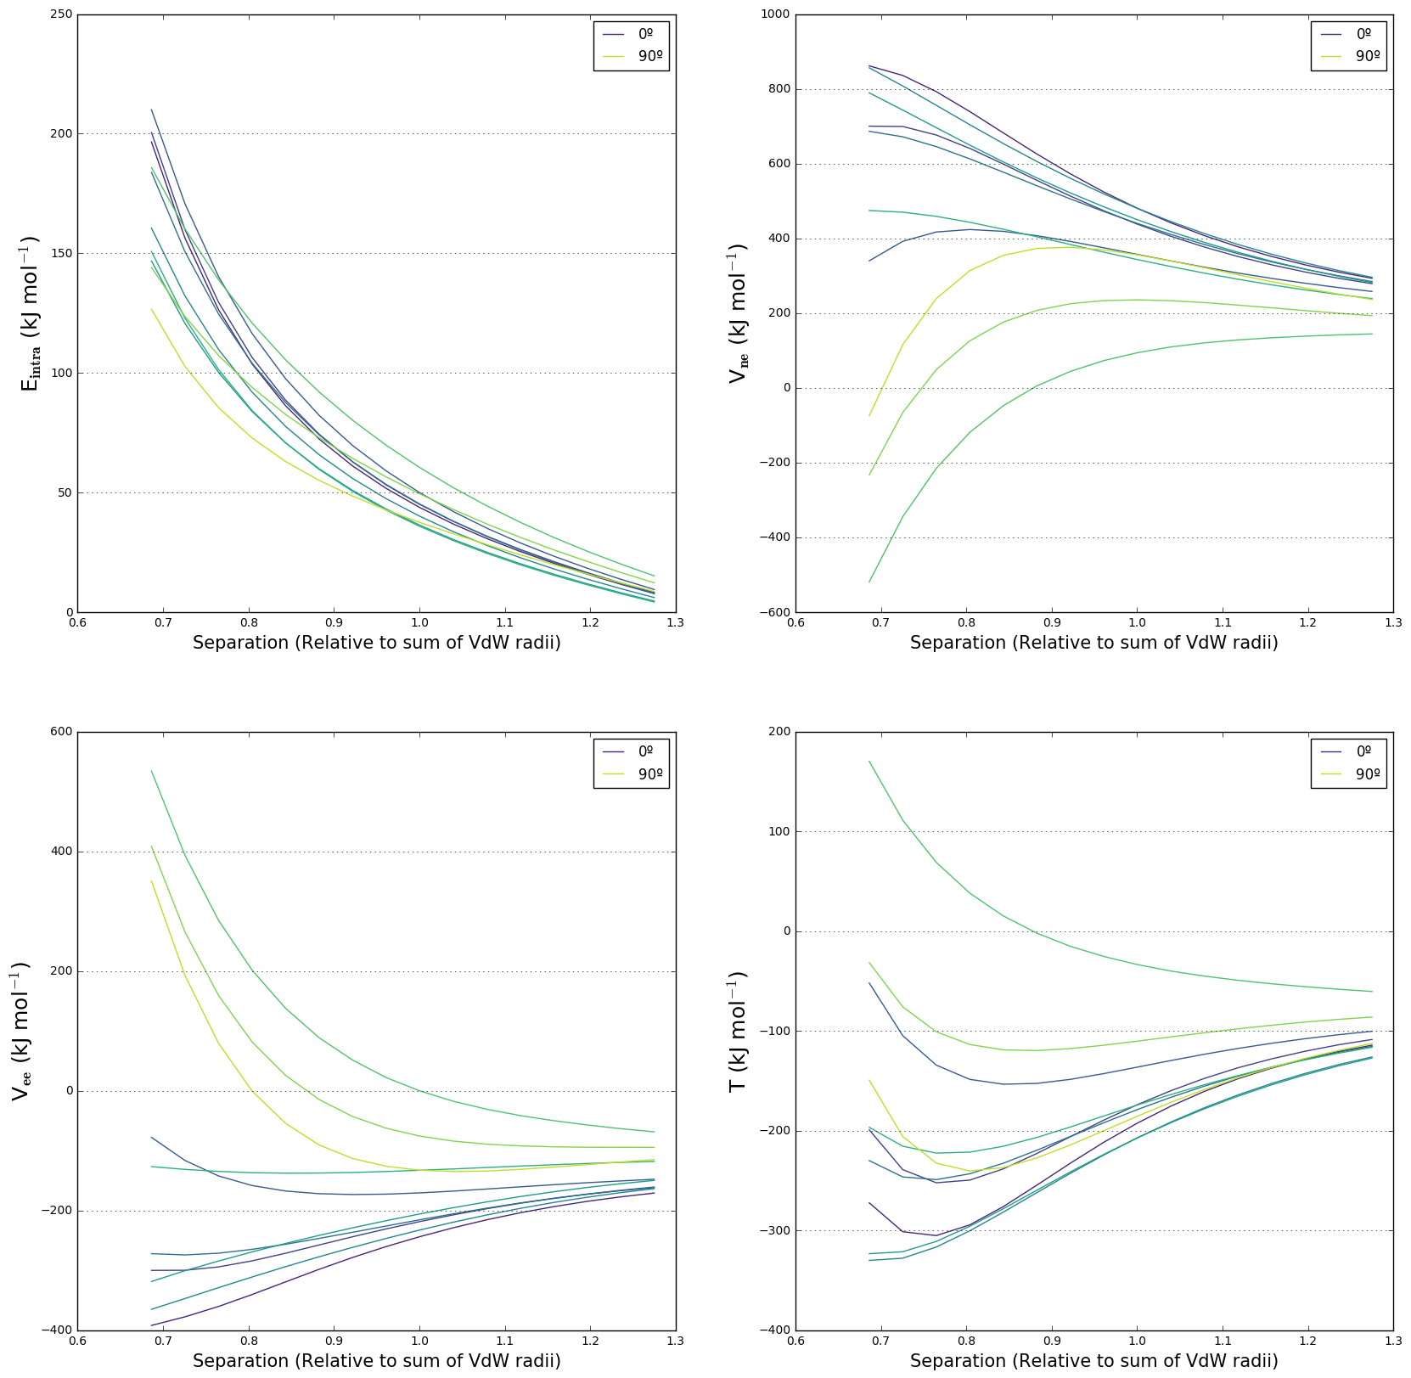

**Figure S5.** Intra-atomic energy and its contributions for all values of θ in the scan.

1.6 F2 dimer

**Table S6.** Energy ranges and exponential fit data for F2 theta scan. Energy ranges and fit data are calculated from a sum of the data for both approaching atoms, whereas volume data pertains to a single atom.

|  |  |  |  |  |  |  |  |
| --- | --- | --- | --- | --- | --- | --- | --- |
| **Theta** | **RMS Error (kJ/mol)** | **Energy Range (kJ/mol)** | **Min Energy (kJ/mol)** | **Max Energy (kJ/mol)** | **Coefficient A** | **Coefficient B** | **Compression of Atomic volume (%)** |
| 0 | 0.8 | 79.6 | -0.8 | 78.7 | 105,749 | 3.3160 | -8.2 |
| 10 | 0.6 | 85.4 | -0.5 | 84.9 | 83,975 | 3.1764 | -8.1 |
| 20 | 0.2 | 94.5 | 0.2 | 94.6 | 47,655 | 2.8674 | -8.1 |
| 30 | 0.2 | 96.5 | 0.9 | 97.5 | 24,974 | 2.5577 | -7.9 |
| 40 | 0.3 | 90.1 | 1.6 | 91.6 | 14,055 | 2.3218 | -7.4 |
| 50 | 0.3 | 78.0 | 1.8 | 79.8 | 8,667 | 2.1625 | -6.8 |
| 60 | 0.2 | 66.0 | 1.7 | 67.8 | 6,321 | 2.0926 | -6.5 |
| 70 | 0.2 | 63.0 | 1.5 | 64.5 | 6,835 | 2.1517 | -7.0 |
| 80 | 0.3 | 81.5 | 1.3 | 82.8 | 13,320 | 2.3447 | -8.3 |
| 90 | 0.8 | 143.7 | 1.4 | 145.1 | 41,188 | 2.6069 | -10.3 |

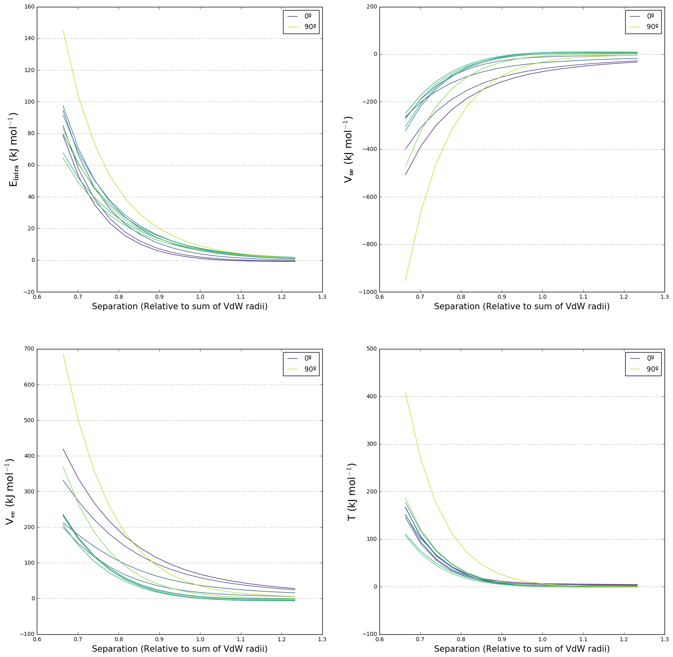

**Figure S6.** Intra-atomic energy and its contributions for all values of θ in the scan.

**2. Hydrogen-bond type approaches (H…X)**

**Table S7.** Energy ranges and exponential fit data for all H…X type approaches. Energy ranges and fit data are calculated from a sum of the data for both approaching atoms, whereas volume data pertains to a single atom. The left-hand volume compression is for the X atom the right-hand for the hydrogen atom.

|  |  |  |  |  |  |  |  |  |
| --- | --- | --- | --- | --- | --- | --- | --- | --- |
| **System** | **RMS Error (kJ/mol)** | **Energy Range (kJ/mol)** | **Min Energy (kJ/mol)** | **Max Energy (kJ/mol)** | **Coefficient A** | **Coefficient B** | **Compression of Atomic volume (%)** | |
| NH3…NH3 | 2.7 | 129.7 | 14.5 | 144.2 | 2,889 | 1.5734 | -12.1 | -38.5 |
| OH2…OH2 | 2.5 | 86.6 | 14.3 | 100.9 | 1,213 | 1.3331 | -5.8 | -35.4 |
| FH…FH | 1.1 | 35.7 | 4.2 | 40.0 | 842 | 1.6591 | -4.0 | -47.0 |
| PH3…PH3 | 0.8 | 82.4 | 3.8 | 86.2 | 2,641 | 1.6212 | -16.9 | -27.1 |
| SH2…SH2 | 1.9 | 89.8 | -2.0 | 87.8 | 22,879 | 2.6386 | -7.0 | -32.8 |
| ClH…ClH | 2.3 | 50.1 | -2.6 | 47.5 | 137,460 | 3.7801 | -5.7 | -24.2 |
| CH­4…NH3 | 1.4 | 133.9 | 9.4 | 143.3 | 4,579 | 1.8071 | -12.8 | -32.8 |
| CH4…OH2 | 1.3 | 111.2 | 7.1 | 118.3 | 4,457 | 1.9144 | -6.6 | -26.8 |
| CH4…FH | 1.1 | 81.6 | 4.5 | 86.1 | 4,460 | 2.1216 | -4.2 | -23.1 |
| NH3…OH2 | 2.5 | 109.0 | 11.8 | 120.8 | 2,627 | 1.6360 | -6.1 | -31.7 |
| NH3…FH | 1.8 | 72.6 | 6.2 | 78.8 | 2,876 | 1.9434 | -4.0 | -27.5 |
| OH2…NH3 | 2.7 | 103.4 | 17.2 | 120.6 | 1,435 | 1.3090 | -11.6 | -41.1 |
| OH2…FH | 1.8 | 57.7 | 6.4 | 64.2 | 1,532 | 1.7248 | -5.1 | -30.9 |
| FH…NH3 | 1.9 | 57.9 | 15.5 | 73.4 | 478 | 1.0039 | -11.2 | -38.6 |
| FH…OH2 | 6.1 | 64.1 | -12.0 | 52.1 | 21,428 | 3.1289 | -5.5 | -35.3 |

For all following figures, decomposed intra-atomic energy plots are displayed on the right and plots of the number of electrons are displayed on the left. The first line of plots gives data for the heavier atom, and the second line of plots gives data for the hydrogen atom.

**2.1. Unmixed systems**

2.1.1 NH3…NH3

|  |  |
| --- | --- |
|  |  |
|  |  |

**Figure S7.** Intra-atomic energies and number of electrons for N and H atoms in the NH3 dimer.

2.1.2 OH2…OH2

|  |  |
| --- | --- |
|  |  |
|  |  |

**Figure S8.** Intra-atomic energies and number of electrons for O and H atoms in the H2O dimer.

2.1.3 FH…FH

|  |  |
| --- | --- |
|  |  |
|  |  |

**Figure S9.** Intra-atomic energies and number of electrons for F and H atoms in the HF dimer.

2.1.4 PH3…PH3

|  |  |
| --- | --- |
|  |  |
|  |  |

**Figure S10.** Intra-atomic energies and number of electrons for N and H atoms in the PH3 dimer.

2.1.5 SH2…SH2

|  |  |
| --- | --- |
|  |  |
|  |  |

**Figure S11.** Intra-atomic energies and number of electrons for S and H atoms in the H2S dimer.

2.1.6 ClH…ClH

|  |  |
| --- | --- |
|  |  |
|  |  |

**Figure S12.** Intra-atomic energies and number of electrons for Cl and H atoms in the HCl dimer.

All intra-atomic energies for atoms in unmixed H…X approaches behave according to the model set out in the discussion. Most hydrogen atoms have intra-atomic energies dictated by the Vne contribution, the exceptions being the PH3 and HCl dimers. In the PH3 dimer, the hydrogen atoms are negatively charged so have more electrons and as such are more affected by atomic compression, so the deformation energies show trends originating from a combination of charge and volume effects. In the HCl dimer, the change in the number of electrons during the approach is an order of magnitude smaller than in other systems; 0.007 electrons in the HCl dimer compared to 0.04 electrons in the H2S dimer. Generally, the maximum deformation of the intra-atomic energies for both atoms decreases as atom X moves along the period, as is evident in the fit coefficients displayed in Table S7. This trend is not rigorous, however, as multiple variables change when X changes.

**2.2. Mixed Systems**

2.2.1 CH4…NH3

|  |  |
| --- | --- |
|  |  |
|  |  |
|  |  |

**Figure S13.** Intra-atomic energies and number of electrons for N and H atoms as a hydrogen atom in CH4 approaches the nitrogen atom in NH3.

2.2.2 CH4…OH2

|  |  |
| --- | --- |
|  |  |
|  |  |

**Figure S14.** Intra-atomic energies and number of electrons for O and H atoms as a hydrogen atom in CH4 approaches the oxygen atom in H2O.

2.2.3 CH4…FH

|  |  |
| --- | --- |
|  |  |
|  |  |

**Figure S15.** Intra-atomic energies and number of electrons for F and H atoms as a hydrogen atom in CH4 approaches the fluorine atom in HF.

2.2.4 NH3…OH2

|  |  |
| --- | --- |
|  |  |
|  |  |

**Figure S16.** Intra-atomic energies and number of electrons for O and H atoms as a hydrogen atom in NH3 approaches the oxygen atom in H2O.

2.2.5 NH3…FH

|  |  |
| --- | --- |
|  |  |
|  |  |

**Figure S17.** Intra-atomic energies and number of electrons for F and H atoms as a hydrogen atom in NH3 approaches the fluorine atom in HF.

2.2.6 OH2…NH3

|  |  |
| --- | --- |
|  |  |
|  |  |

**Figure S18.** Intra-atomic energies and number of electrons for N and H atoms as a hydrogen atom in H2O approaches the nitrogen atom in NH3.

2.2.7. OH2…FH

|  |  |
| --- | --- |
|  |  |
|  |  |

**Figure S19.** Intra-atomic energies and number of electrons for F and H atoms as a hydrogen atom in H2O approaches the nitrogen atom in HF.

2.2.8. FH…NH3

|  |  |
| --- | --- |
|  |  |
|  |  |

**Figure S20.** Intra-atomic energies and number of electrons for N and H atoms as the hydrogen atom in HF approaches the nitrogen atom in NH3.

2.2.9. FH…OH2

|  |  |
| --- | --- |
|  |  |
|  |  |

**Figure S21.** Intra-atomic energies and number of electrons for O and H atoms as the hydrogen atom in HF approaches the oxygen atom in H2O.

The intra-atomic energies for mixed H…X approaches also behave according to the model set out in the discussion. Here, the periodic trends are easier to identify as only one molecule is changed at a time. For example, for the series CH4…NH3 to CH4…FH, the maximum deformation of intra-atomic energy for both atoms decreases as atom X increases in mass. For the series CH4…NH3, NH3…NH3, OH2…NH3, FH…NH3, the maximum deformation of intra-atomic energy for both atoms also decreases.

**3. Hydrogen-hydrogen approaches (H…H)**

**3.1. Unmixed systems**

3.1.1 CH4…H4C

|  |  |
| --- | --- |
|  |  |

**Figure S22.** Intra-atomic energies and number of electrons for a single H atom as it approaches its mirror in the CH4 dimer.

3.1.2 NH3…H3N

|  |  |
| --- | --- |
|  |  |

**Figure S23.** Intra-atomic energies and number of electrons for a single H atom as it approaches its mirror in the NH3 dimer.

3.1.3 OH2…H2O

|  |  |
| --- | --- |
|  |  |

**Figure S24.** Intra-atomic energies and number of electrons for a single H atom as it approaches its mirror in the H2Odimer.

3.1.4 FH…HF

|  |  |
| --- | --- |
|  |  |

**Figure S25.** Intra-atomic energies and number of electrons for a single H atom as it approaches its mirror in the HFdimer.

These experiments are commented on at length in the discussion. Hydrogen atoms in CH4 are essentially neutral and experience little change in the number of electrons as one hydrogen atom approaches another, so the deformation in its intra-atomic energy is determined by the T contribution and is therefore exponentially positive. In the other experiments, the hydrogen atoms are charged and experience significant increases the number of electrons as they approach each other. This leads to dominance of the Vne contribution which is greater in magnitude than both the T and Vee contributions and increasingly negative deformation in intra-atomic energy. The more positive the charge on the hydrogen atom, the more negative the intra-atomic deformation energy.

**3.2. Mixed systems**

For all following figures, data for the first hydrogen atom is displayed in the top row, and data for the second hydrogen atom is displayed in the second row. For example, in the CH4…NH3 approach, data for the hydrogen atom in methane is presented first, then data for the hydrogen atom in ammonia is presented second.

3.2.1. CH4…H3N

|  |  |
| --- | --- |
|  |  |
|  |  |

**Figure S26.** Intra-atomic energies and number of electrons for the hydrogen atom in CH4 (top) and the hydrogen atom in NH3 (bottom) as they approach each other.

3.2.2 CH4…H2O

|  |  |
| --- | --- |
|  |  |
|  |  |

**Figure S27.** Intra-atomic energies and number of electrons for the hydrogen atom in CH4 (top) and the hydrogen atom in H2O (bottom) as they approach each other.

3.2.3 CH4…HF

|  |  |
| --- | --- |
|  |  |
|  |  |

**Figure S28.** Intra-atomic energies and number of electrons for the hydrogen atom in CH4 (top) and the hydrogen atom in HF (bottom) as they approach each other.

3.2.4. NH3…H2O

|  |  |
| --- | --- |
|  |  |
|  |  |

**Figure S29.** Intra-atomic energies and number of electrons for the hydrogen atom in NH3 (top) and the hydrogen atom in H2O (bottom) as they approach each other.

3.2.5 NH3…HF

|  |  |
| --- | --- |
|  |  |
|  |  |

**Figure S30.** Intra-atomic energies and number of electrons for the hydrogen atom in NH3 (top) and the hydrogen atom in HF (bottom) as they approach each other.

3.2.6. OH2…HF

|  |  |
| --- | --- |
|  |  |
|  |  |

**Figure S31.** Intra-atomic energies and number of electrons for the hydrogen atom in H2O (top) and the hydrogen atom in HF (bottom) as they approach each other.

The data from the mixed H…H approaches is consistent with the model outlined in the discussion. All atoms experience comparable increases in electrons as they approach their counterpart, and the extent to which the deformation in intra-atomic energy is determined by the T contribution or the Vne contribution depends on the charge of the atom. Highly charged atoms have few electrons to be affected by an atomic compression but are equally influenced by changes to electron population so are proportionately more dependent on charge deformations.

**4. Relaxed experiments**

The intra-atomic energy data for rigid experiments were subtracted from the data for corresponding relaxed experiments to calculate the deviation between them.

4.1 HF theta scan

**Table S8.** Energy ranges and exponential fit data for the relaxed HF theta scan. Energy ranges and fit data are calculated from a sum of the data for both approaching atoms, whereas volume data pertains to a single atom. The fit data in Table S8 follow very similar trends to the rigid scan in Table S3.

|  |  |  |  |  |  |  |  |
| --- | --- | --- | --- | --- | --- | --- | --- |
| **Theta** | **RMS Error (kJ/mol)** | **Energy Range (kJ/mol)** | **Minimum Energy (kJ/mol)** | **Maximum Energy (kJ/mol)** | **Coefficient A** | **Coefficient B** | **Compression of Atomic Volume (%)** |
| 0 | 2.0 | 146.4 | 4.5 | 151.0 | 20,865 | 2.4032 | -7.6 |
| 10 | 2.0 | 147.9 | 4.5 | 152.4 | 21,457 | 2.4122 | -7.7 |
| 20 | 1.9 | 152.2 | 4.3 | 156.5 | 23,024 | 2.4332 | -7.8 |
| 30 | 1.8 | 159.1 | 4.1 | 163.2 | 25,133 | 2.4550 | -8.0 |
| 40 | 1.6 | 167.8 | 3.8 | 171.6 | 27,412 | 2.4718 | -8.1 |
| 50 | 1.4 | 177.3 | 3.5 | 180.7 | 29,797 | 2.4862 | -8.5 |
| 60 | 1.1 | 186.3 | 3.0 | 189.3 | 32,641 | 2.5072 | -8.7 |
| 70 | 0.8 | 193.8 | 2.4 | 196.8 | 36,248 | 2.5393 | -9.0 |
| 80 | 0.6 | 200.1 | 1.8 | 201.9 | 40,905 | 2.5831 | -9.3 |
| 90 | 0.5 | 206.6 | 1.4 | 208.0 | 46,005 | 2.6251 | -9.7 |
| 100 | 0.7 | 216.5 | 0.8 | 217.4 | 52,593 | 1.6675 | -10.2 |
| 110 | 0.5 | 219.3 | 1.3 | 220.5 | 46,332 | 2.5958 | -10.6 |
| 120 | 0.2 | 232.9 | 2.6 | 235.5 | 38,520 | 2.4769 | -10.9 |
| 130 | 0.9 | 250.7 | 5.0 | 255.7 | 28,130 | 2.2805 | -11.0 |
| 140 | 3.0 | 272.1 | 7.8 | 279.9 | 20,617 | 2.0775 | -10.5 |
| 150 | 7.9 | 295.3 | 9.5 | 304.8 | 19,219 | 1.9844 | -10.0 |
| 160 | 4.9 | 217.6 | 9.4 | 227.0 | 10,192 | 1.8375 | -5.0 |
| 170 | 7.3 | 186.4 | 8.6 | 195.0 | 313,946 | 3.2390 | -5.6 |
| 180 | 20,559 | 35.8 | 7.6 | 43.4 | 837,408 | 1.2805 | -7.2 |

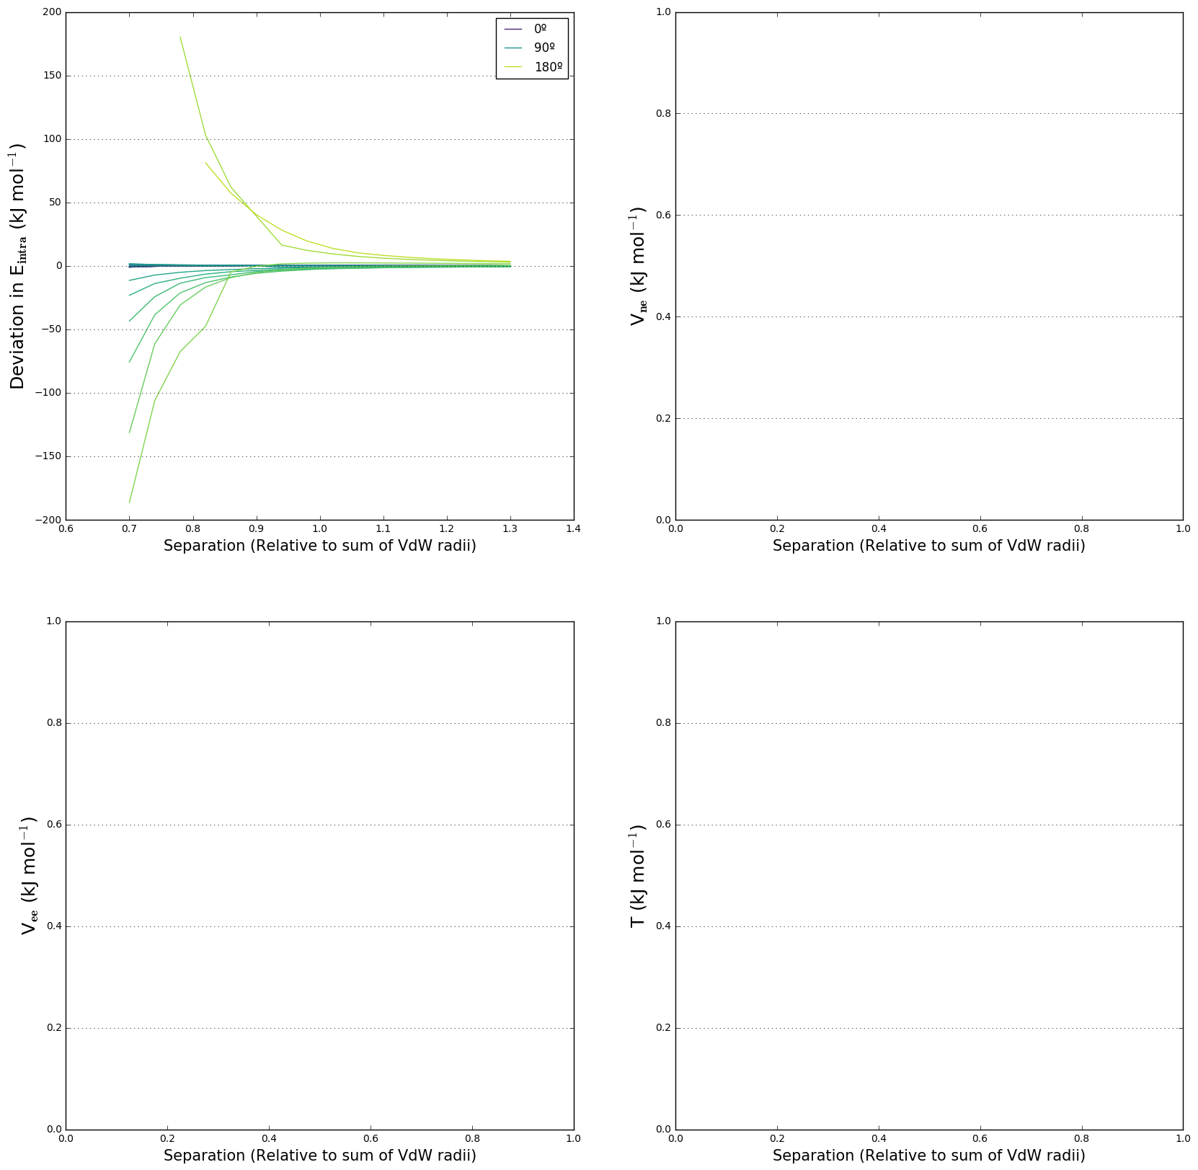

**Figure S32.** Gradient plot showing the deviation of the relaxed experiment from the rigid experiment.

4.2 NH3…NH3

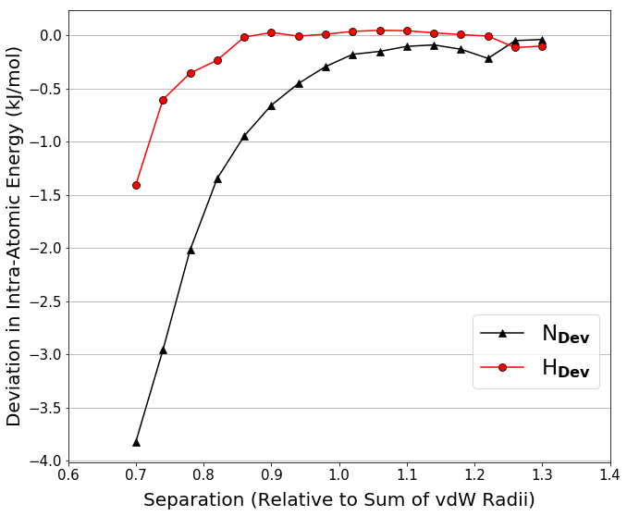

**Figure S33.** Deviations in the intra-atomic energies of approaching hydrogen and nitrogen atoms between relaxed and rigid NH3 molecules.

**Table S8.** Energy ranges and exponential fit data for this approach. Fits were calculated for the sums of the intra-atomic energies of the approaching atoms.

|  |  |  |  |  |  |  |
| --- | --- | --- | --- | --- | --- | --- |
| **System** | **RMS Error** | **Energy Range (kJ/mol)** | **Min Energy (kJ/mol)** | **Max Energy (kJ/mol)** | **Coefficient A** | **Coefficient B** |
| NH3…NH3 | 2.4 | 124.6 | 14.4 | 139.0 | 2,604 | 1.5376 |

4.3 NH3…H3N

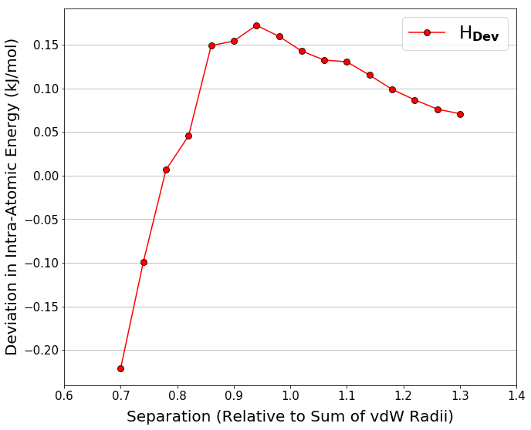

**Figure S34.** Deviation in the intra-atomic energy of an approaching hydrogen atom between relaxed and rigid NH3 molecules.

4.4 OH2…OH2

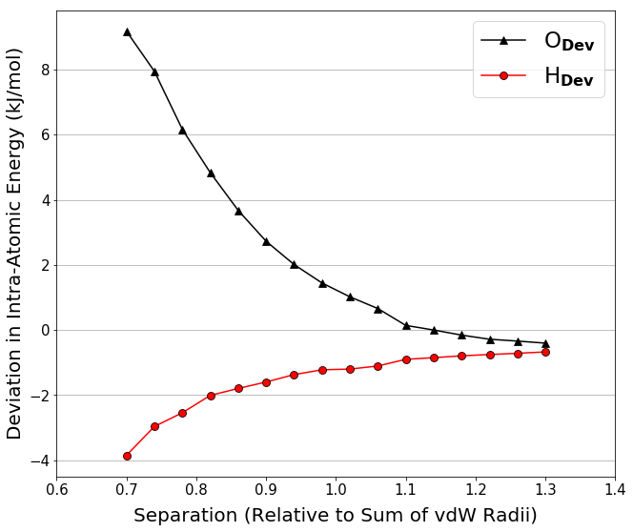

**Figure S35.** Deviations in the intra-atomic energies of approaching hydrogen and oxygen atoms between relaxed and rigid H2O molecules.

**Table S9.** Energy ranges and exponential fit data for this approach. Fits were calculated for the sums of the intra-atomic energies of the approaching atoms.

|  |  |  |  |  |  |  |
| --- | --- | --- | --- | --- | --- | --- |
| **System** | **RMS Error** | **Energy Range (kJ/mol)** | **Min Energy (kJ/mol)** | **Max Energy (kJ/mol)** | **Coefficient A** | **Coefficient B** |
| H2O-H2O | 2.2 | 93.1 | 13.2 | 106.3 | 1,521 | 1.4180 |

4.5 OH2…H2O

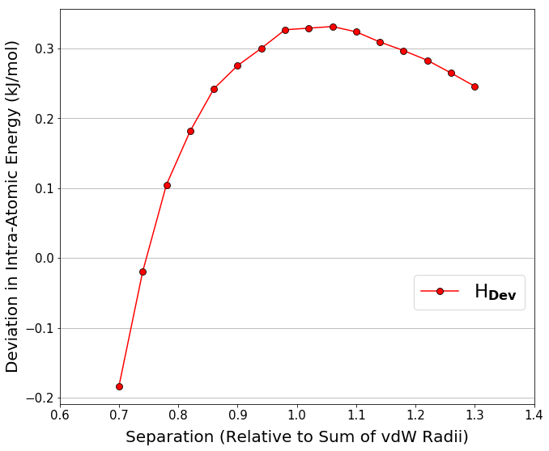

**Figure S36.** Deviation in the intra-atomic energy of an approaching hydrogen atom between relaxed and rigid H2O molecules.

The deviations increase as separation decreases, and the relaxed systems are generally lower energy than the rigid ones, however this is not the case for the oxygen atom in the OH2…OH2 approach. Although one might always expect the intra-atomic energy to be lower in a relaxed system than a rigid one, this is only one component of the total energy that is minimised during geometry optimisation so any increases in intra-atomic energy upon relaxation will be offset by reductions in other energies.